**Test Document for Additional information PO Delivery Status**

Test for PO P20100003

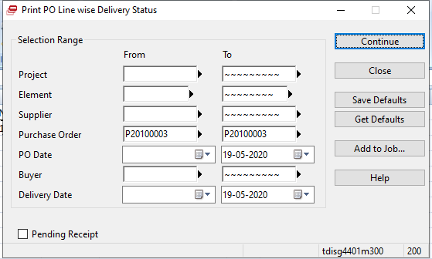

Results are:

